CPAISD V12 Final Report
High-resolution 2.5D supervised NCCT ischemic-area segmentation
Date: 2026-06-04
Cloudflare viewer: https://32c21435.cpaisd-v11-v12-viewers.pages.dev

Executive Summary
The final selected model is V12_penumbra, a high-resolution 2.5D supervised U-Net-style model. The primary target is ischemic area, defined as core plus penumbra. V12_core was trained separately using core-only masks and is reported as an exploratory auxiliary model.

Model Schematic
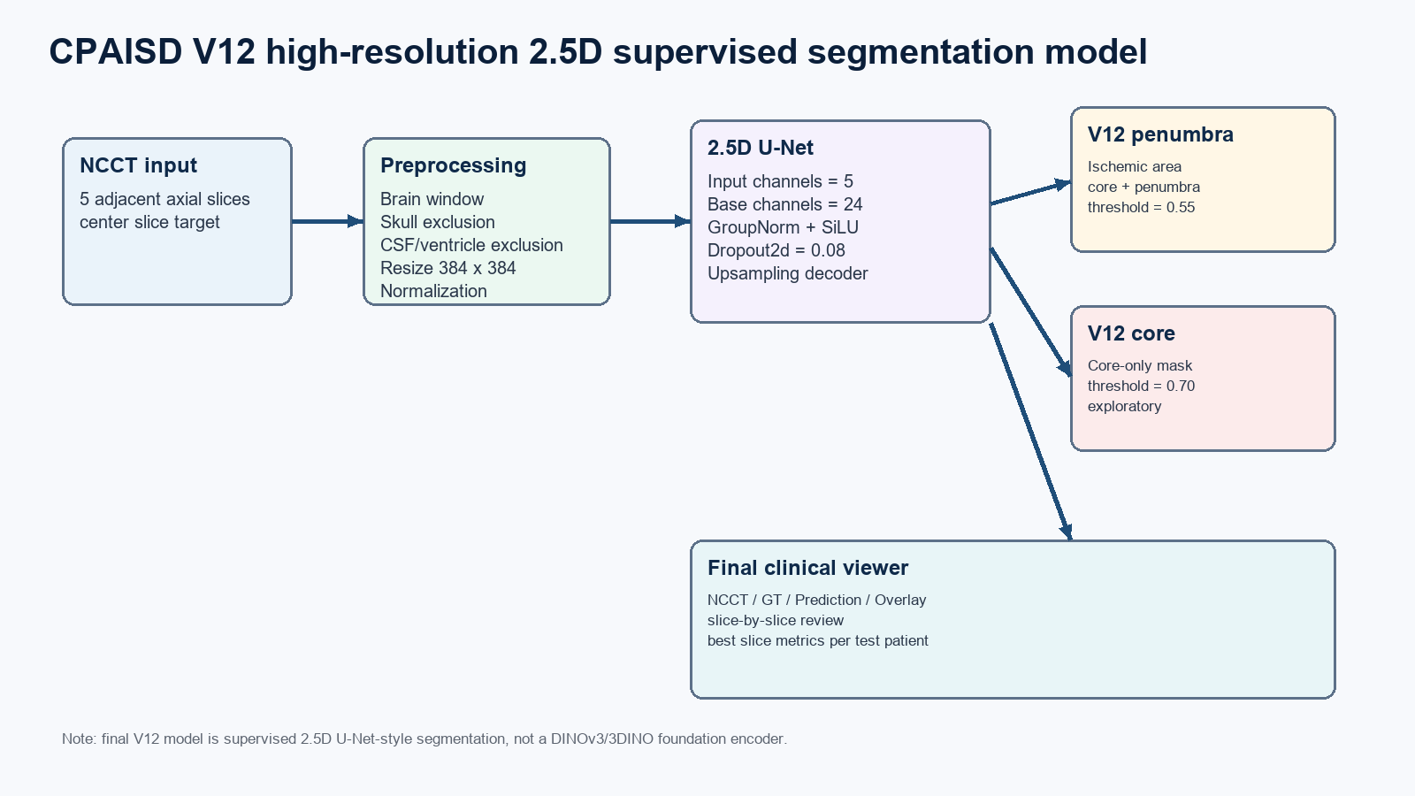

Final Test Metrics
Model | Target | Threshold | Dice | IoU | Precision | Recall
V12_penumbra | core + penumbra | 0.55 | 0.4217 | 0.2672 | 0.5505 | 0.3418
V12_core | core-only | 0.70 | 0.0701 | 0.0363 | 0.0734 | 0.0670

Training Parameters
Parameter | Value
Input size | 384 x 384
Input context | 5 adjacent axial slices
Folds | 5
Epoch budget | 35
Batch size | 2
Optimizer | AdamW
Learning rate | 0.0001
Weight decay | 0.0005
U-Net base channels | 24
Dropout2d | 0.08
Early stopping patience | 7
Tissue HU range | 18.0 to 90.0 HU
Tversky alpha / beta | 0.75 / 0.25
BCE positive weight | 2.0
Augmentation | rotation +/-7.0 deg; scale 0.94 to 1.06

5-fold Validation
Fold | V12_penumbra Dice | V12_penumbra Val Loss | V12_core Dice | V12_core Val Loss
1 | 0.3622 | 0.5706 | 0.2850 | 0.5180
2 | 0.4311 | 0.5659 | 0.2968 | 0.4978
3 | 0.4119 | 0.5458 | 0.2347 | 0.5151
4 | 0.3679 | 0.5463 | 0.2782 | 0.5112
5 | 0.2843 | 0.5629 | 0.2817 | 0.4835

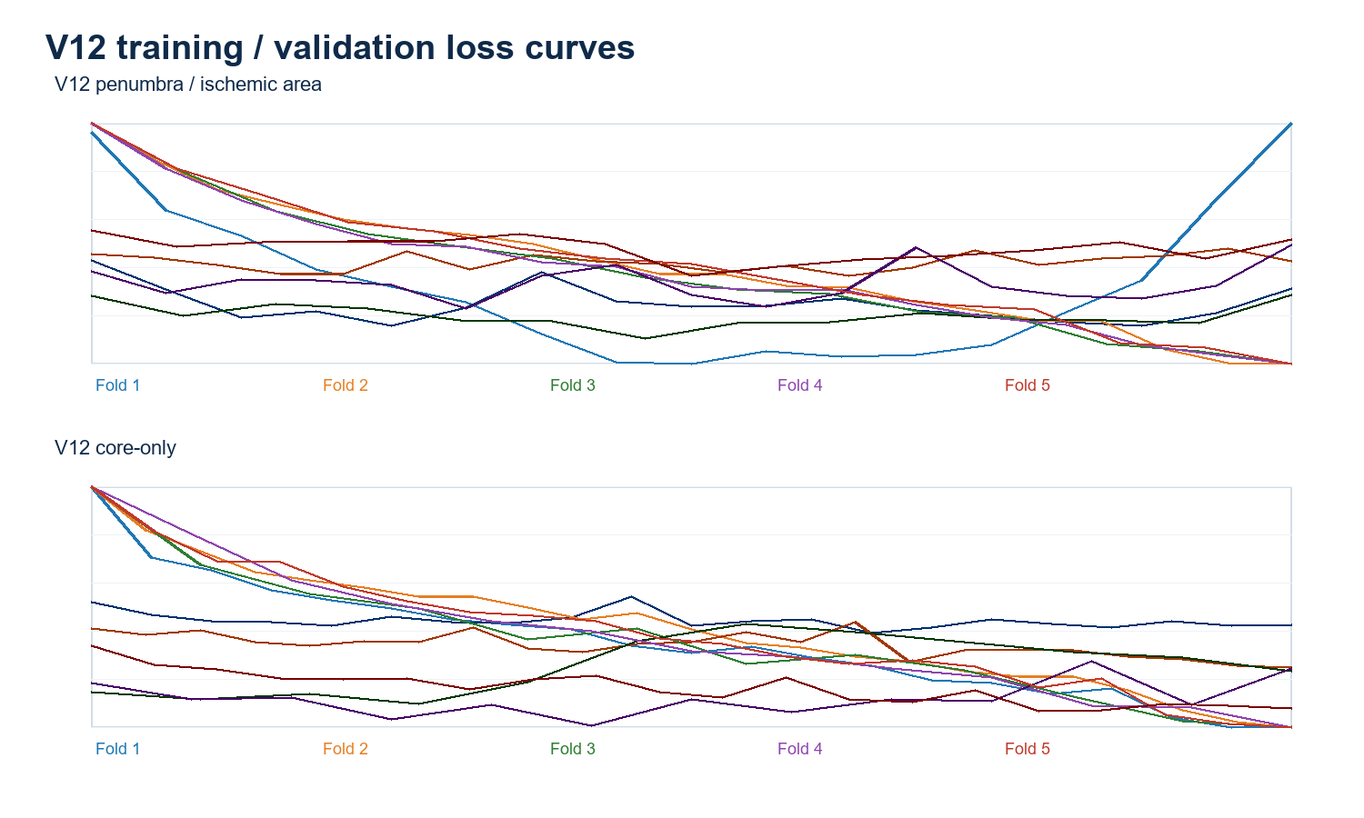

Preprocessing and Target Definition
- Brain-window NCCT clipping and intensity normalization were applied before model input.
- High-HU skull components were excluded, and water-density CSF/ventricle regions were suppressed using the tissue HU range.
- V12_penumbra uses the union of core and penumbra masks as the binary ischemic-area target.
- V12_core uses only core label value 1 as the target and is more severely imbalanced.

Interpretation
The V12_penumbra model is recommended as the final report model. The separate V12_core model provides an auxiliary view but currently has weak held-out test generalization, reflecting the smaller lesion volume and greater label imbalance.

